Software Requirements Specification

for

Elysium

Version 1.0

Prepared by

Group: 13 Group Name: aleph-7

|  |  |  |
| --- | --- | --- |
| Aditi Khandelia | 220061 | aditikh22@iitk.ac.in |
| Gottupulla Venkata Aman | 220413 | gvaman22@iitk.ac.in |
| Mahaarajan J | 220600 | mahaarajan22@iitk.ac.in |
| Kushagra Srivastava  Sankalp Mittal  Aditya Jagdale  Wattamwar Akanksha  Ritesh Baviskar  Arush Upadhyaya  Animesh Madaan | 220573  220963  220470  221214  220286  220213  220145 | skushagra22@iitk.ac.in  sankalpm22@iitk.ac.in  jagdale22@iitk.ac.in  akankshab22@iitk.ac.in  [baviskars22@iitk.ac.in](mailto:baviskars22@iitk.ac.in)  [arushu22@iitk.ac.in](mailto:arushu22@iitk.ac.in)  manimesh22@iitk.ac.in |
|  |  |  |

**Course: CS253**

**Mentor TA: Mr. Sarthak Neema**

**Date: 26 January 2024**

Contents i

Revisions ii

1 Introduction 1

1.1 Product Scope 1

1.2 Intended Audience and Document Overview 1

1.3 Definitions, Acronyms and Abbreviations 2

1.4 Document Conventions 2

1.5 References and Acknowledgments 3

2 Overall Description 4

2.1 Product Overview 4

2.2 Product Functionality 5

2.3 Design and Implementation Constraints..................................................................................9

2.4 Assumptions and Dependencies 9

3 Specific Requirements 10

3.1 External Interface Requirements 10

3.2 Functional Requirements 13

3.3 Use Case Model 15

4 Other Non-functional Requirements 22

4.1 Performance Requirements 22

4.2 Safety and Security Requirements 22

4.3 Software Quality Attributes 22

Appendix A – Data Dictionary 24

Appendix B - Group Log 26

Revisions

| Version | Primary Author(s) | Description of Version | Date Completed |
| --- | --- | --- | --- |
| Draft Type and Number | Full Name | Information about the revision. This table does not need to be filled in whenever a document is touched, only when the version is being upgraded. | 00/00/00 |

# 

# Introduction

## Product Scope

IITK, being one of the largest campuses in India, also boasts large number of extra-curricular facilities. But these facilities pale in comparison to the number of students and employees leading to a shortage of facilities. This is mainly because there is no proper system for a streamlined usage of facilities leading to lack of equipment or large queues for the facilities which demotivate a person from using these. Long queues, hassle of finding people, equipment and courts to play brings a lot of stress for the players and demotivates people from using these facilities. The envisioned sports and mental health facilities management app aims to tackle these issues by streamlining the process of using various sports and mental well-being facilities for both the user and the administrator.

With a robust and easy-to-use UI, our app provides all the features to tackle the issues which may deter a person from pursuing their well-being. We provide an advanced court booking system where players will be able to book the courts and equipment for casual plays among peers. In addition, we will also be introducing a ranking system which enables players with no opponents in their circle match with an opponent and then book the courts based on their preference ensuring fruitful experience for the players via friendly competition.

For beginners who have no experience in the sports of their choice, we will also be providing tutoring options where they can book sessions with coaches to learn the sport. Also, we will be providing safe payment options wherein the all the sports, gym, pool etc. facilities and tutoring sessions payments will be done in a safe and secure way. By integrating with various other features like equipment booking, access to common facilities, yoga and therapist appointments the app aims to provide a one stop solution for users to unwind and access all physical and mental well-being infrastructure present in the institution.

For the coaches, it provides a one stop solution to manage and utilise the vast variety of facilities to their maximum level. It shall also be a means to collect and analyse data regarding the usage of these facilities and further use them to make necessary improvements.

Our team believes that these features are essential to promote an enthusiastic community in the campus and we will ensure this by making this app available to all the users free of cost*.*

## Intended Audience and Document Overview

This software requirement documentation written to be used and understood by:

* Software Development Team and Individual Contributors that will design and construct this software as per the requirements of a particular institution, in this case the SPEC (Sports and Physical Education Committee) and ICS (Institute Counselling Service), Indian Institute of Technology Kanpur.
* Product Managers, in this case the Teaching Assistants and Course Instructor, whose responsibility is to overlook the planning, development and execution of the software development.
* Testers, who perform product and quality checks and carry out extensive testing and perform a quality check on the designed software and give their feedback on the interface, areas of improvement, etc.
* End-Users, that is the IIT Kanpur students, Sports Coaches, Yoga Instructors and Counsellors, that might find this document relevant.

**Section 1:**

In this section, we introduce the users to the basic terminologies and information that will help them read and understand the SRS. This section can be ignored if the user if familiar with the terminology. This section provides a basic overview of the entire document.

**Section 2:**

This section offers precise and concise information regarding the functionality, interface, assumptions and dependencies of the app. It is an effective read to familiarize the user with the app. All users are encouraged to go through this section for a fair understanding of the SRS document.

**Section 3:**

This section offers a detailed description of the software, its functionality and working by dividing the entire user experience into multiple use cases. This section states the basic requirements to use the app. Each use case discusses the way the app functions and enables users to accomplish the goals. The end-users are required to go through this section to realize the requirements to fully utilize the app.

**Section 4:**

This section informs the end-users regarding important non-functional requirements which they must follow to enjoy a fruitful experience. This section is a must read for all the users.

## Definitions, Acronyms and Abbreviations

* **SRS** Software Requirement Specification
* **UI** User Interface
* **ICS** Institute Counselling Service
* **SPEC** Sports and Physical Education Committee
* **DBMS** Database Management System
* **FCFS** First Come First Serve
* **MTTF** Mean Time to Failure
* **DDOS** Distributed Denial of Service

## Document Conventions

While preparing this document, to make readability user-friendly and important parts clear, we have

used the following conventions:

* The headings of all the sections are written in **bold** and underlined using Arial font size 14.
* The headings of subsections are **bold** and written in the same font as that of content using font size 13.
* The content of the section is written in Arial font size 11.
* Any important term or short form is written in **bold**.
* The alignment of the whole content is **justified**.
* Text has been indented wherever required to highlight the hierarchy of the content.
* The document follows the IEEE formatting, indenting, and numbering conventions. Any deviations from the same will be explicitly specified.

## References and Acknowledgments

**References:**

Style Guide (for this document) : [IEEE Software Requirements Specification Template.](https://www.ieee.org/content/dam/ieee-org/ieee/web/org/conferences/style_references_manual.pdf)

**Acknowledgment:**

The fundamental principles of our system design were established through the lecture notes and guidance provided by Professor Dr. Indranil Saha, along with the invaluable assistance of our Teaching Assistant, Sarthak Neema.

# Overall Description

## Product Overview

The motivation behind this project is to streamline the mental and physical health of campus residents. To solve the limited availability of slots in sports facilities across campus such as Tennis, Badminton, Squash, Basketball, Volleyball, Gym, Swimming Pool, etc., we plan on implementing an advanced slot-booking and priority platform. The application will also display the free slots available and contain a gateway to pay for the facilities. It will also allow the user to book equipment in advance. We plan on implementing a pair-matching functionality based on player strength in multiplayer games, with a display of player rankings to inculcate healthy competition. It will also allow coaches to take in a batch of students according to their availability and train them in their respective sports.

The wellness sections will include self-help resources, meditation sessions, option to book slots for yoga sessions and book an appointment with the Counselling Service. The client (the owner of the facilities) will have an option to look at the data collected in a holistic manner to make a well-informed managerial decision. The user will have an option to look at the number of hours they spent on their wellness.

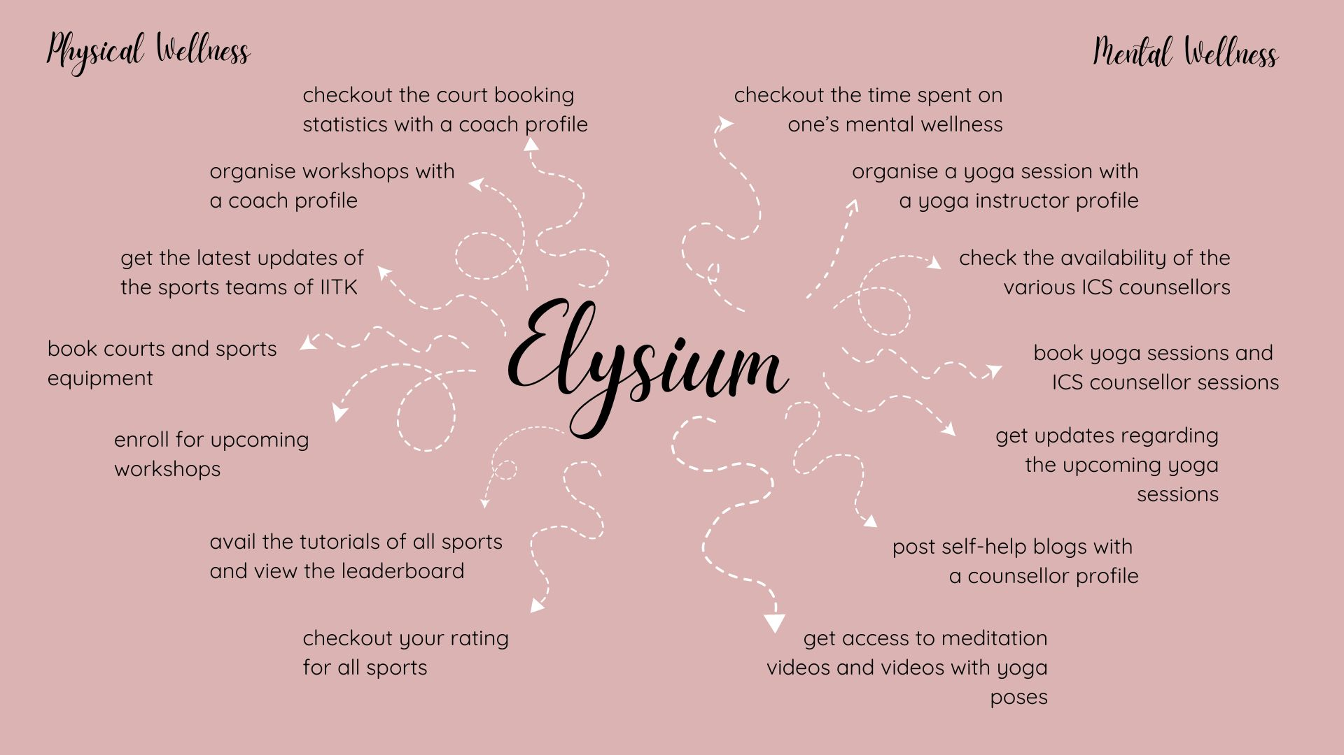

## Product Functionality

* **User Dashboard**

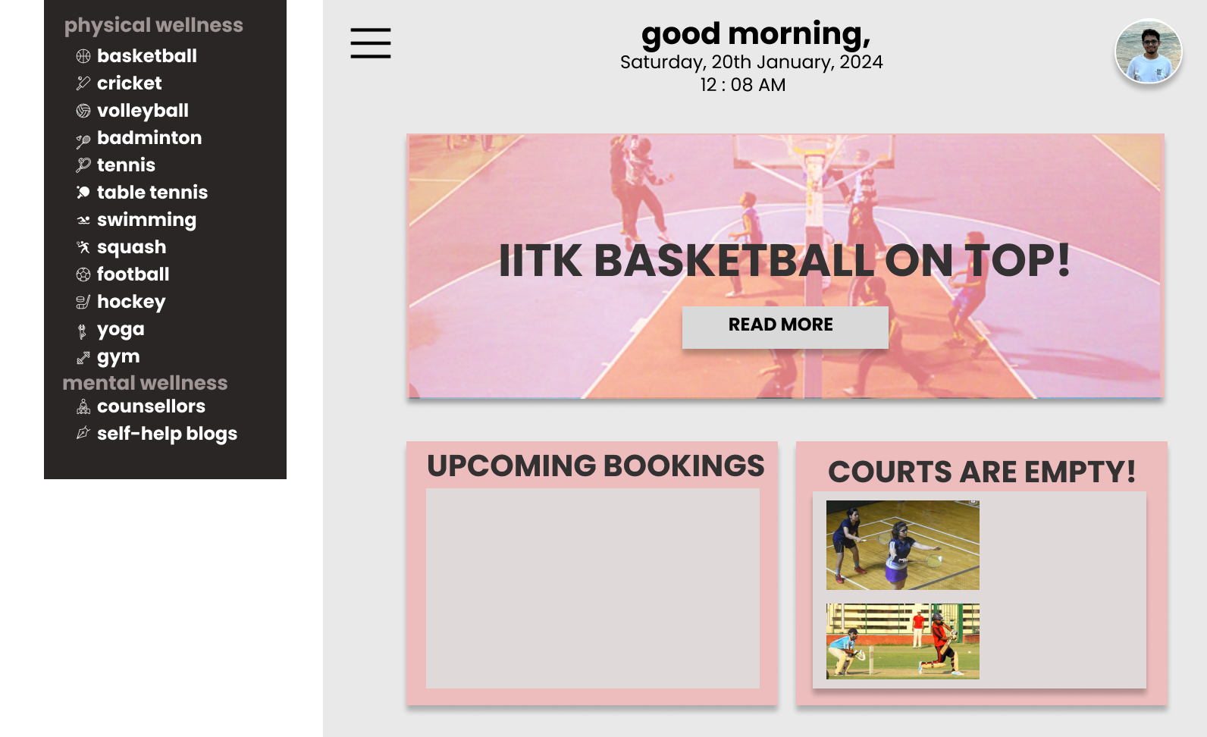The dashboard will be divided into three sections to assist the users, i.e. IIT Kanpur students. The first section will give them the option to book a sports facility, yoga session or an appointment with a counsellor. The second section will show the upcoming bookings of the user. The third section will show the current availabilities i.e. courts that are currently vacant. The side navigation bar will be divided into two sections, one for physical wellness and the other for mental wellness. The physical wellness section will enlist the various sports whose facilities are available in IITK. The mental wellness section will contain links to avail the facilities of yoga, of the ICS counsellors as well as self-help blogs.

* **User Profile Page**

Every IIT Kanpur student, will have a personal account which will contain a detailed tabular history of their bookings, their rating, their acceptance history as well as the number of hours played.

* + Booking History

The booking history will be divided into two sections, one pertaining to the sports sections and the other to the wellness section.

* + - Sports Section

Each entry in this section will correspond to a past or pending booking. It will contain the sport requested for, the date and time slot it was requested for, the status of the request (i.e. rejected, accepted, or pending). For each accepted request the entry will show whether the user availed the slot at the expected time.

* + - Wellness Section

Each entry in this section will contain information regarding a past or pending request for a yoga section or an ICS counsellor appointment. This information will contain the date and time of the slot, the counsellor requested for and the status of the request (i.e. rejected, accepted, or pending).

* + Rating
    - This will be the metric used for the purpose of matchmaking, that will be displayed to the user. The methodology for computing this metric is mentioned later in this document.
  + Acceptance history
    - 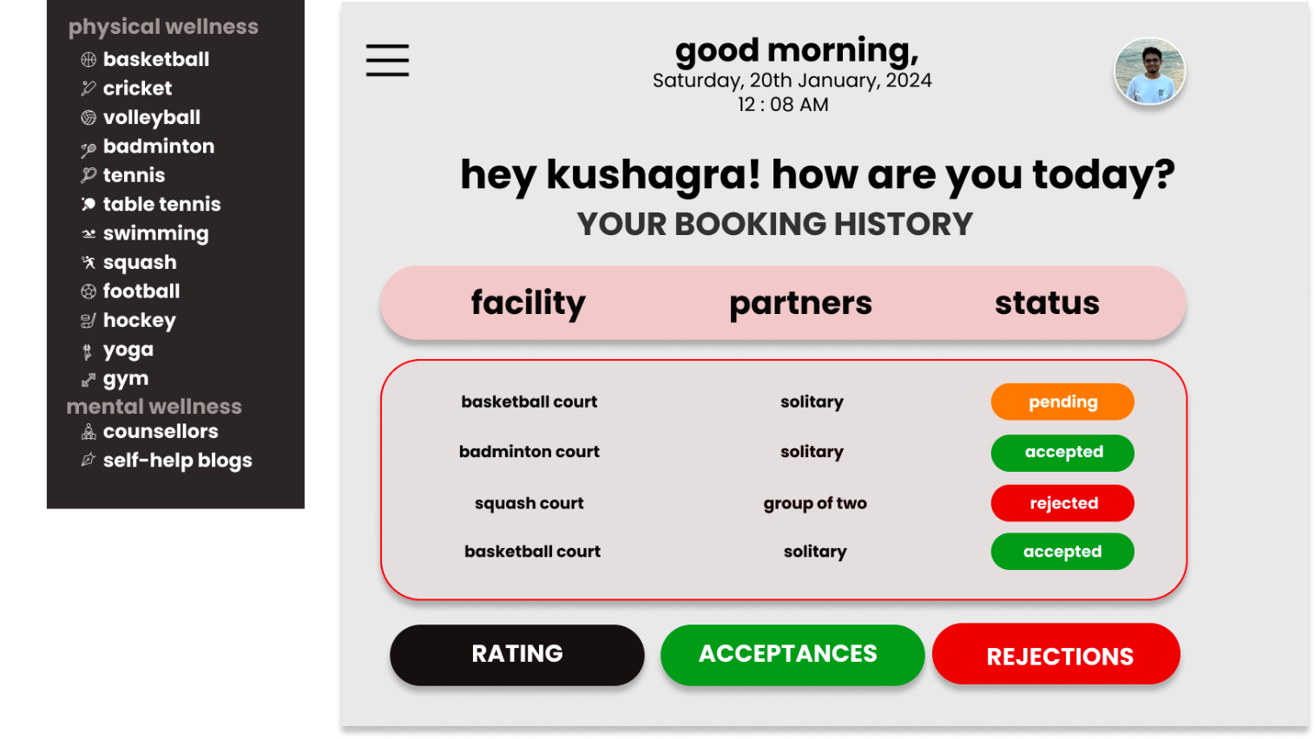This will be the metric used for the purpose of resolving clash in booking of sports facilities.
* **Sports Coach’s Dashboard**

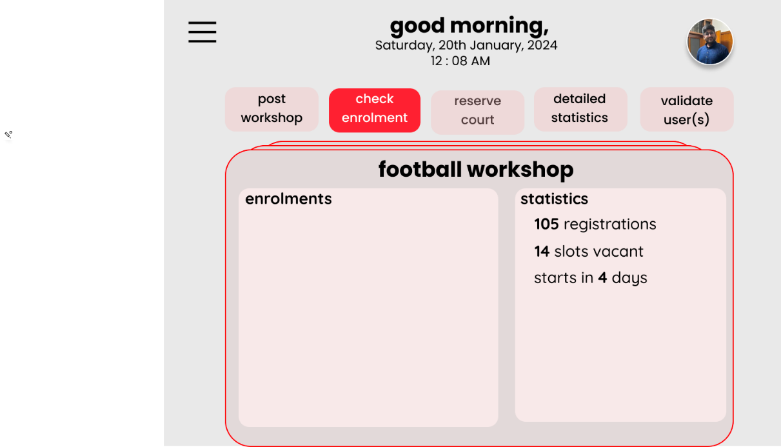Every coach of every sport in IIT Kanpur will have a dashboard. This page will allow them to put up posts regarding upcoming workshops as well as view the trends of court occupancy during different durations of the day.

* **Counsellor’s Dashboard**

All the ICS counsellors will have a personal dashboard. This page will allow them to accept appointment requests from students, post blogs as well as view the trends of appointment bookings during different durations of the day.

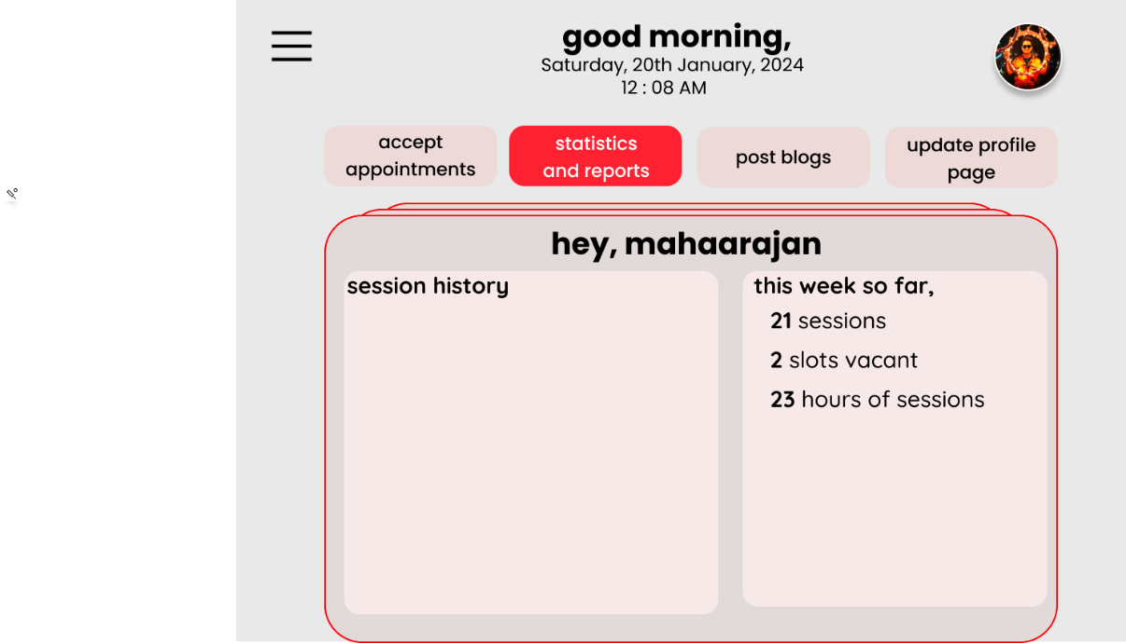

* **Yoga/Gym/Swimming Instructor’s Dashboard**

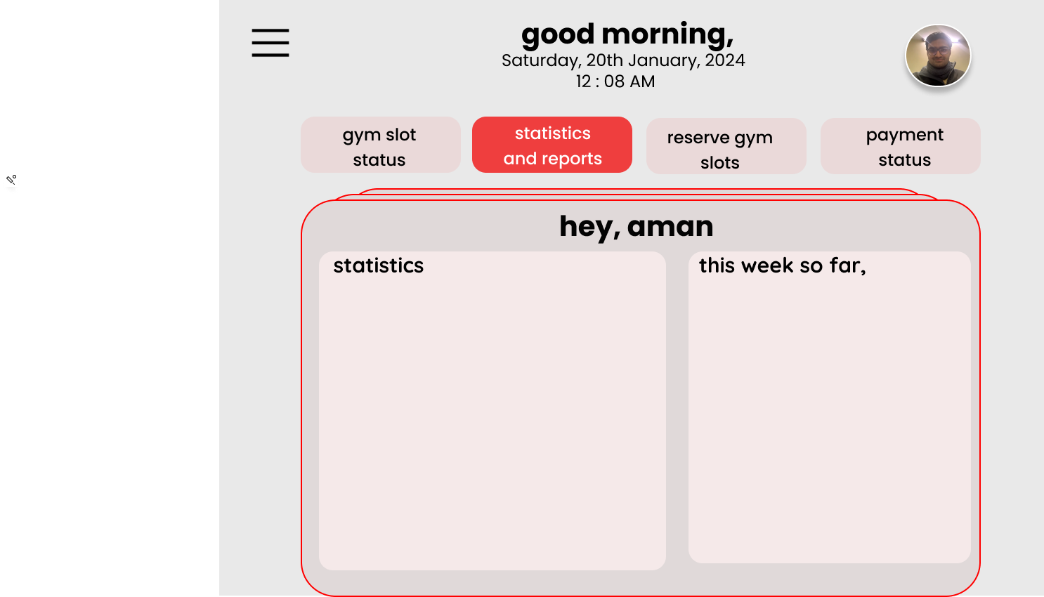All the yoga, gym or swimming instructors will have a dashboard. This page will allow them to put up posts regarding upcoming sessions as well as show the trends of hall occupancy during different durations of the day. They can also see reports of payment status and trends.

* **Sport’s Page**

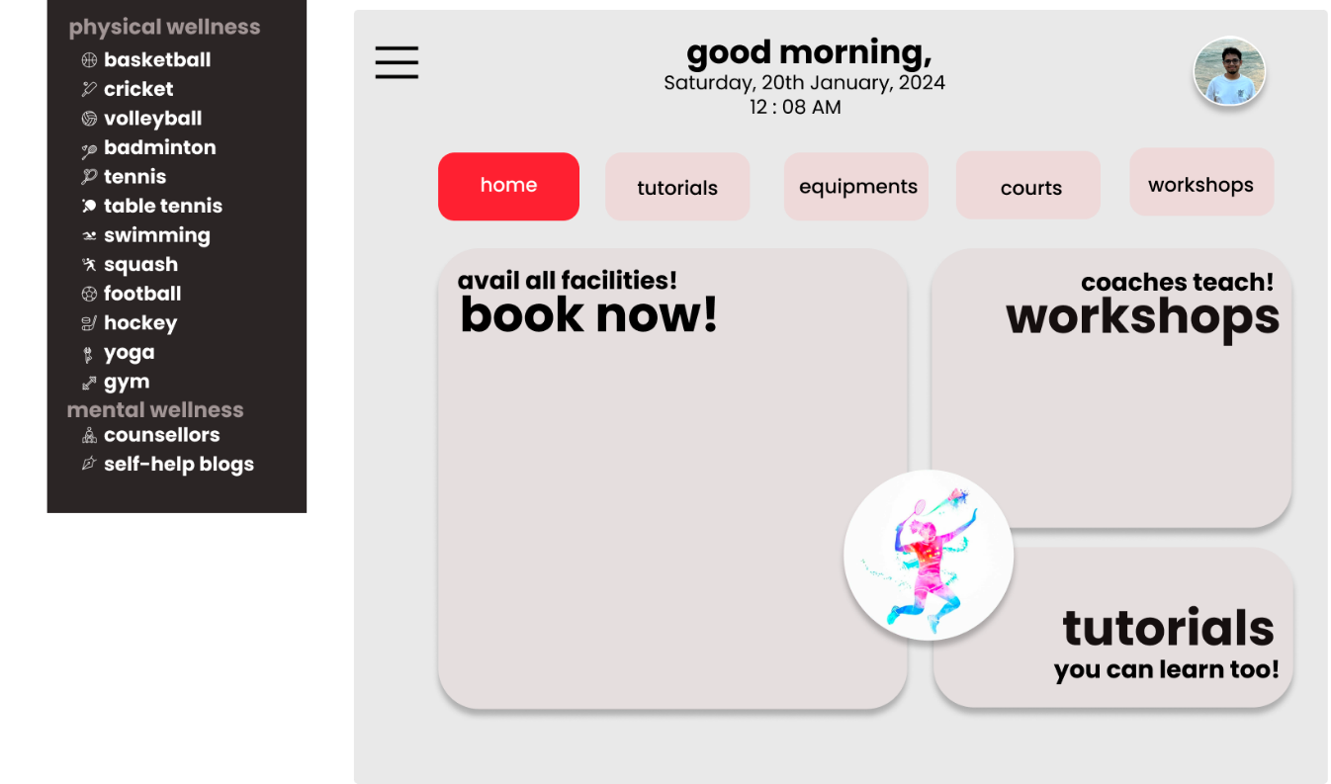This page will contain all the required information regarding the concerned sport, including the tutorials of that sport, the leaderboard as well as the upcoming workshops. The page will allow the user to book the concerned sport’s courts and other equipment.

* **Yoga Page**

This page will allow users to book yoga halls and mats as well as provide information about the upcoming yoga sessions, allowing them to enroll for the same.

* **Gym/Swimming Pool Page**

This page will allow users to gym and swimming pool sessions and allow users to pay the fees for their slot and

* **Counsellor’s Page**

This page will introduce the ICS and its counsellors. It will allow the users to check the usual availability times for the various counsellors and allow them to book appointments with the same.

* **Self-help Blogs**

This will display the various blog posts by the ICS and its counsellors on a variety of subjects that help improve the mental well-being of the campus community.

## Design and Implementation Constraints

* The reservations database is an integral part of the relevance of the software, and its memory needs to be sufficient.
* The events database is an integral part of the relevance of the software, and its memory needs to be sufficient, for the timely addition (and updating) of events.
* The server should have enough resources and compute power available to accommodate and serve all the users and the data requested by the users, without delay.
* A user without administrator access should not be able to access the data available to the admins.

## Assumptions and Dependencies

* The maximum number of users that will be registered on the application will be 10,000.
* The number of users that get allotted a particular workshop will not exceed 100.
* At any point of time, there shall be at least one account with admin privileges for each sport. The access to these accounts will be given to the Coaches, Counsellors, Yoga Instructors, and support staff, such as SIS Guards.
* The administrator account will be used so that users that have booked a slot can be verified, and new upcoming workshops can be added to the servers.
* workshops can be added only six months into the future.
* Upcoming new technology shall not affect the execution of the application.

# Specific Requirements

## External Interface Requirements

### User Interfaces

The application will be of use to different category of users, necessitating **five main login types**.

This will be the format of the **user’s dashboard**. This will show the latest announcements and updates regarding vacant courts. This will allow the users to view their upcoming bookings as well as view their profile. The navigation bar provides an interface for the user to avail both the sections of the application- physical and mental wellness.

Below will be the format of the **sports coach’s dashboard**. This will allow the coaches to manage the upcoming workshops (make announcements, handle bookings etc.). It will also show the trends of occupancy of courts.

Below will be the format of the **counsellor’s dashboard**. This will allow the counsellors to post blogs regarding self-help, accept appointment requests from students as well as view trends of appointments.

Below will be the format of the **yoga instructor’s dashboard**. This will allow the instructors to announce and manage upcoming yoga sessions as well as view trends of occupancy of yoga halls.

The navigation bar’s first section will enlist all the sports in the campus. Each of these sports will have its own landing page, whose interface is given below.

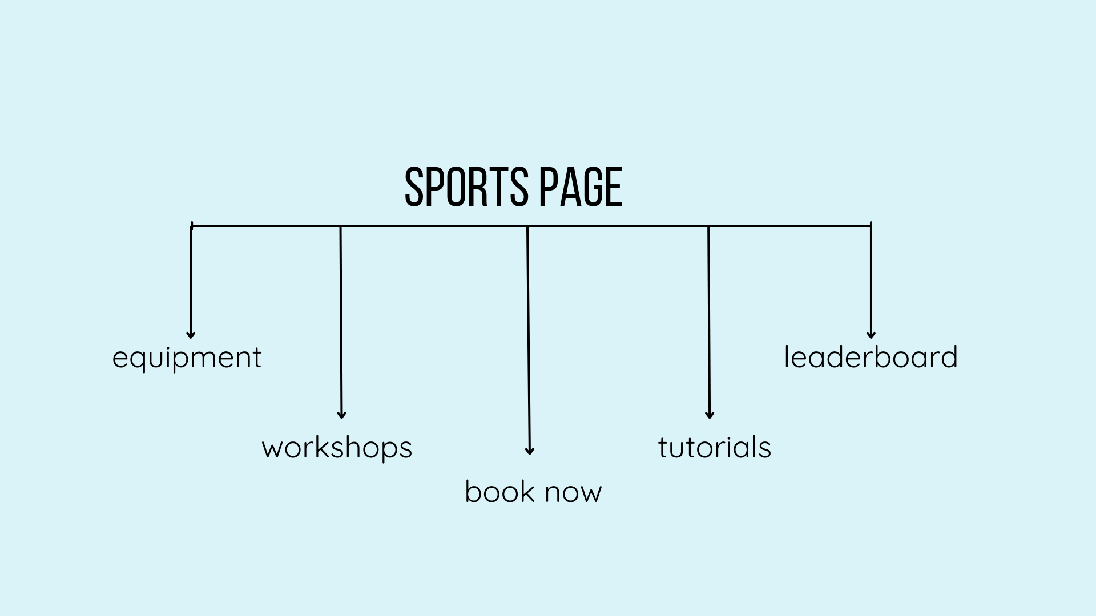

The wellness section is going to contain these sections. The counsellors’ section will open to a new page with profiles of all available counsellors, their available timings and might be linked to book an appointment.

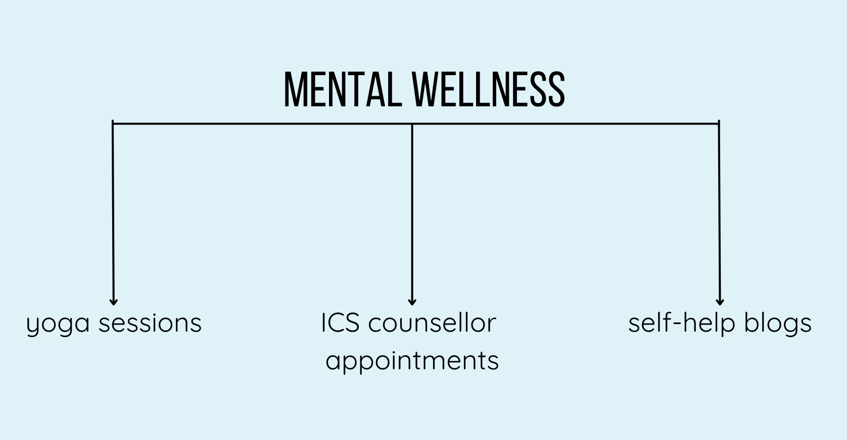

### Hardware Interfaces

* A desktop at every court which will allow the attender to verify the attendance of the player to whom the court was allotted.
* Support for modem and Ethernet card – for accessing the internet to access the software.
* The server side of the system must be connected to the intranet to ensure safe login.

### Software Interfaces

* The client-side components of the software must be able to operate seamlessly with various modern web browsers like Apple Safari 7+, Google Chrome 44+, Microsoft Edge 90+, Mozilla Firefox 40+.
* For ensuring authenticity of users the software shall verify credentials with the institute database.
* We will use multiple databases for storing the following: -
  + User login credentials
  + Rating data
  + Slots’ data
  + Counsellors’ data
  + Yoga instructors’ data
  + Coaches’ data
  + Equipment data for each sport
  + Payment details

We shall be using MongoDB as our DBMS.

## Functional Requirements

### 3.2.1 A service for slot and equipment booking in sports facilities

### Slot Booking

* Users will be able to view available time slots for various sports (Tennis, Squash, Badminton, Table Tennis, Gym, Swimming, Wall Climbing, Ball Pool, Hockey, Cricket, Football).
* Users can specify their preferred time range for a desired sport, as part of an advanced booking.
* The system will assign a time slot within the user's specified range, if available and an algorithm will be used on the basis on which we will prioritize users with more rejections in previous bookings.
* Confirmation notification will be sent upon successful booking, a few hours before the slot.
* In the case of facilities with a lot of slots and where regular slots are required like the gym/swimming pool a FCFS system will be followed to book for the entire month.

### Unbooked Courts/ No show

* In case a court is unbooked or someone who booked the court fails to show up, this will be notified to users who are interested in that sport.
* In case a person books and doesn't show up in a certain window the court will be listed as open to play. Also, that person will get lower priority during his next booking.

### Sports Equipment Booking

* Users will be able to view and book equipment available for specific sports (Tennis, Squash, Badminton, Table Tennis).
* Booking confirmation and equipment pickup/return instructions will be provided.

## 3.2.2 A functionality for match making and tracking performance

* Our system will intelligently assign opponents (when required) to players for multiplayer games, based on their caliber.
* Using a rating system for this caliber will also allow us to maintain a leaderboard for each game.
* It will also keep a track of their rating and maintain a local ladder.

## 3.2.3 A functionality for providing resources and opportunity for new players to acquire skills in a sport

* The system shall provide a comprehensive library of tutorials, blogs, and general tips for each sport.
* Tutorials shall include:
  + Step-by-step instructions with text and visual aids (images or videos).
  + Clear and concise explanations of techniques and strategies.
  + Categorization by sport and skill level.
* Blogs shall feature:
  + Articles written by experts in various sports.
  + Informative content on training, strategies, equipment, and motivation.
  + User-friendly organization and search functionality.
* General tips shall offer:
  + Practical advice on various aspects of sports performance.
  + Easy-to-digest format for quick reference.

## 3.2.4 A service for booking counseling sessions with Institute Counseling Service

* Our system will also provide a platform for conveniently booking counseling sessions.
* It will give announcements/notifications about any health-related talks/sessions being held in the campus and give reminder for the same, if opted for.

## 3.2.5 Functionalities available to the coaches

* Coaches can reserve courts for team practice, these courts will then not be available for booking for the public.
* Coaches can also mark booking as absent if the people who have booked a slot do not show up.
* They can also update about any workshops or coaching sessions they might be giving.

## Use Case Model

### Use Case #1

**Author** - This use case was written by Animesh Madaan and Arush Upadhyaya.

**Purpose** - To allow users to book sports courts and facilities and select which user gets the resource requested for in case of clash, taking into account users’ booking histories.

**Requirements** **Traceability** - This feature settles conflicts in reservations and assigns a booking priority according to a set of criteria derived from the user's past reservations.

**Priority** - This use case has a high priority since system users won't be able to reserve slots if the system malfunctions.

**Pre-conditions** -Users interested in booking a slot must pick the slots of availability.

**Post**-**conditions** - The users will get notified if they get a slot. And if they do not, they have the option to book a slot in “active” booking.

**Actors** - Actors in this use case are the students acting as the users.

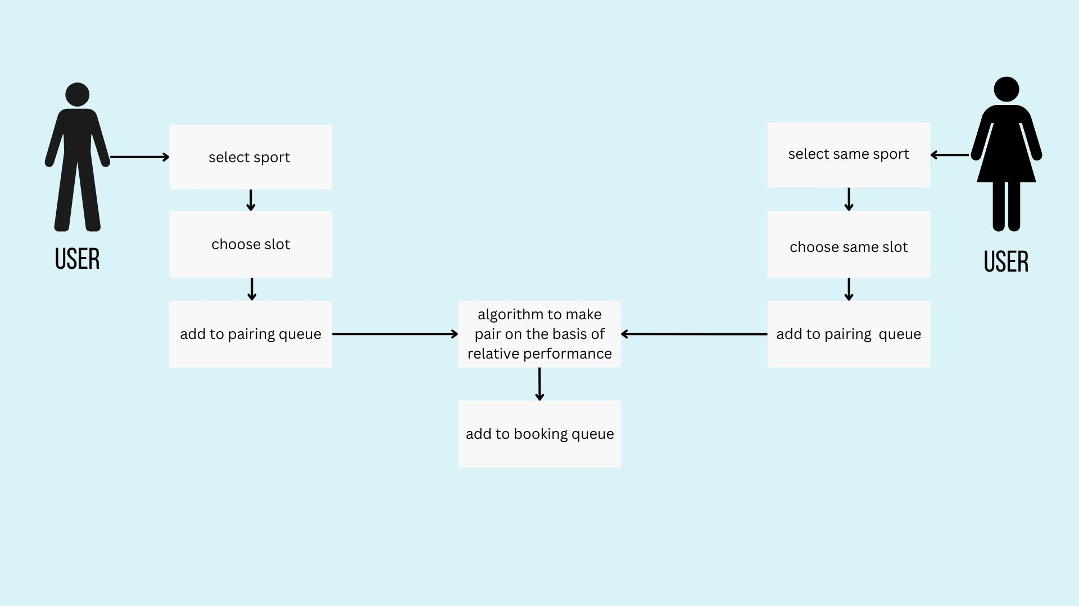

### 3.3.2 Use Case #2

**Author** - This use case was written by Aditi Khandelia and Kushagra Srivastava.

**Purpose** - To allow yoga instructors to post about yoga sessions and allow the users to register for the same.

**Requirements Traceability** -To handle the announcements of upcoming yoga sessions and manage the same. To handle registration of these yoga sessions.

**Priority** - The priority of this use case is high. Mental wellness is an essential component of the system and yoga sessions are pivotal to the students’ mental and physical wellbeing.

**Preconditions** - The yoga instructors need to have a yoga instructor’s profile which will allow them to post about upcoming yoga sessions. The users will have a user profile that allows them to view upcoming sessions and register for the same. Users will also be sent a notification when yoga instructor posts about a new workshop.

**Post conditions** - The users will be sent a notification if their request to register in a session gets accepted. In case of acceptance, the session will appear in the schedule of the user. The number of people registered for the session will also be reflected on the instructor’s dashboard.

**Actors** - Yoga instructors for posting about sessions and student users for registering for the same.

**Exceptions** - There are no exceptions in this use case.

**3.3.3 Use Case #3**

**Author** - This use case was written by Animesh Madaan.

**Purpose** - Functionality for users to book appointments with therapists of the Institute Counselling Service.

**Requirements Traceability** -In order to handle appointments, such as accepting reservations and rescheduling appointments, counsellors need to have a profile with administrative rights. To schedule sessions, the user also must have an account.

**Priority** - At its core, this app is about making mental health services easily accessible. It is imperative that this use case be executed flawlessly. These hiccups seriously impair our main goal. Therefore, the priority of this functionality is high.

**Preconditions** - The therapists must indicate in-person when they are available and suggest a time for future appointment scheduling.

**Post conditions** - The user should be notified after approval of their booking by the therapist.

**Actors** - Counsellors for managing bookings and students for booking sessions.

### 3.3.4 Use Case #4

**Author** - This use case was written by Aditi Khandelia and Arush Upadhyaya.

**Purpose** - To allow users to apply for monthly/ yearly gym and pool memberships.

**Requirements Traceability** -This use case is required by the users who want to avail the gym or swimming facilities for a specific timeframe.

**Priority** - The priority of this use case is medium. This is because the primary purpose of our software is to ensure easy access to the physical wellness and mental wellness facilities on campus and most of them remain functional even if this use case fails.

**Preconditions** - A schedule displaying the available time slots for availing the gym and pool facilities on campus. The user should have a profile from where they can apply for membership.

**Post conditions** - The users will be sent a notification if their request for membership is accepted. Payments will be made through SBI icollect upon receiving the notification by the user. This will lead to confirmation of membership.

**Actors** - Users to apply for gym and pool memberships.

**Exceptions** - There are no exceptions in this use case.

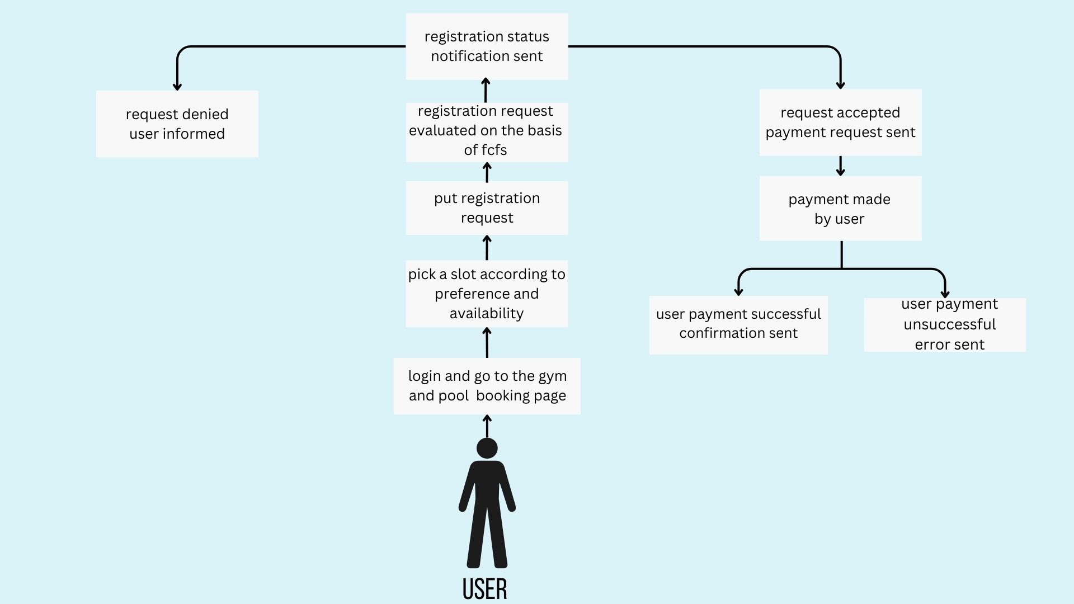

### Use Case #5

**Author** -This use case was written by Maharajan J and Sankalp Mittal.

**Purpose** - To pair individuals who are looking for playmates.

**Requirements Traceability** -Many users might not have a partner to play the game with, so this feature allows them to find playmates and enjoy the game.

**Priority** - The priority of this use case is medium as it is one of the additional features of this application and any problems in this use case will decrease the scope of this application.

**Preconditions** - The selection of sport and the preferred timeslot(s) must be completed before the pair matching begins.

**Post conditions** - The user can check after the booking period is over whether they have been allotted a pair and a court and will get the details of their partner and their allotted timeslot.

**Actors** - The players who need a playmate will be the ones triggering this use case.

**Exceptions** - If there are odd number of people looking for a pair one person will not be a part of any pair and will not be included in the slot allotment algorithm.

**Includes** - Use Case #1



**3.3.6 Use Case #6**

**Author** - This use case was written by Gottupulla Venkata Aman and Ritesh Baviskar.

**Purpose** -To inform users about upcoming workshops and open registration.

**Requirements Traceability** -The coaches and counsellors will have access to a common database which they will update regarding workshops and events within a certain timeframe. Also, coaches and counsellors and students will have access to the app which will notify them regarding upcoming sessions.

**Priority** - The priority of this use case is medium. The app will still retain its main functionality even if this use case fails.

**Preconditions -** The coaches and counsellors should update the database as and when required.

**Post conditions** - The users have the sessions and workshops in their upcoming schedule and all users will be notified.

**Actors -** Coaches and counsellors for scheduling sessions and students for booking sessions.

**Exceptions -** Users who have opted out of the notifications will not be notified.

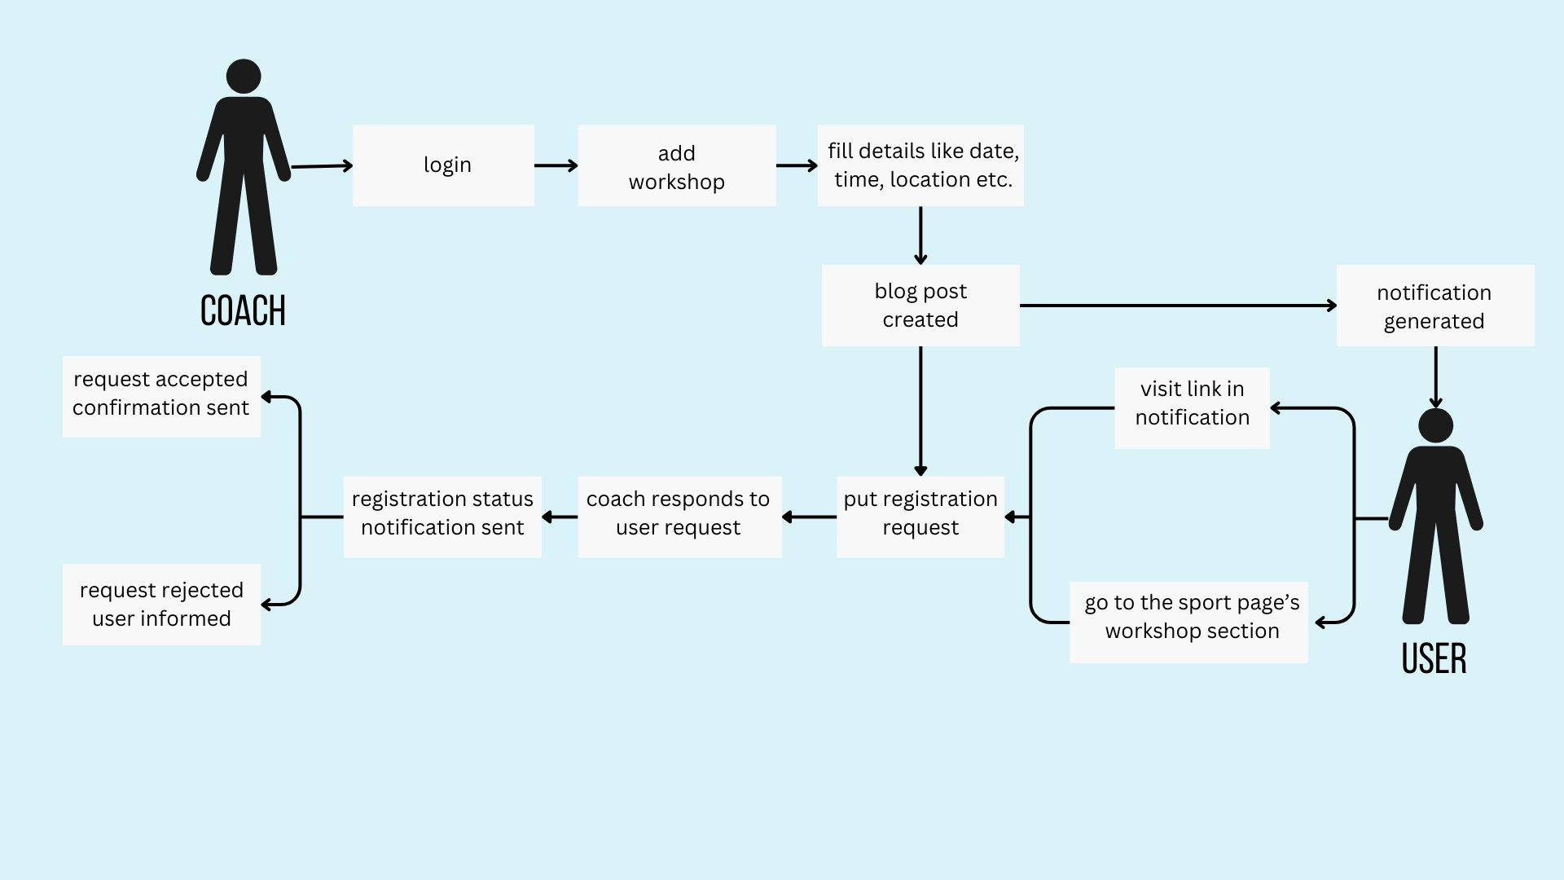

### Use Case #7

**Author** - This use case was written by Aditya Jagdale and Akanksha Wattamwar.

**Purpose** - To ensure the timely entry of users in accordance with their booked schedule and validate availability of courts.

**Requirements Traceability -** The staff must have signed up on their respective portal as an admin.

**Priority -** The priority of this use case is medium. The application will still be complete without it.

**Preconditions** - Require users to present their respective institute ID cards upon arrival.

**Post conditions** -

* Ensure user validation when the user arrives at the respective booked location punctually.
* If a user fails to arrive on time, impose a penalty, and subsequently, after a designated period, send a notification indicating that the current time slot is now available.
* If a user arrives before the designated period, adjust and reduce the imposed penalty accordingly.

**Actors** -Actors in this use case are users and staff.

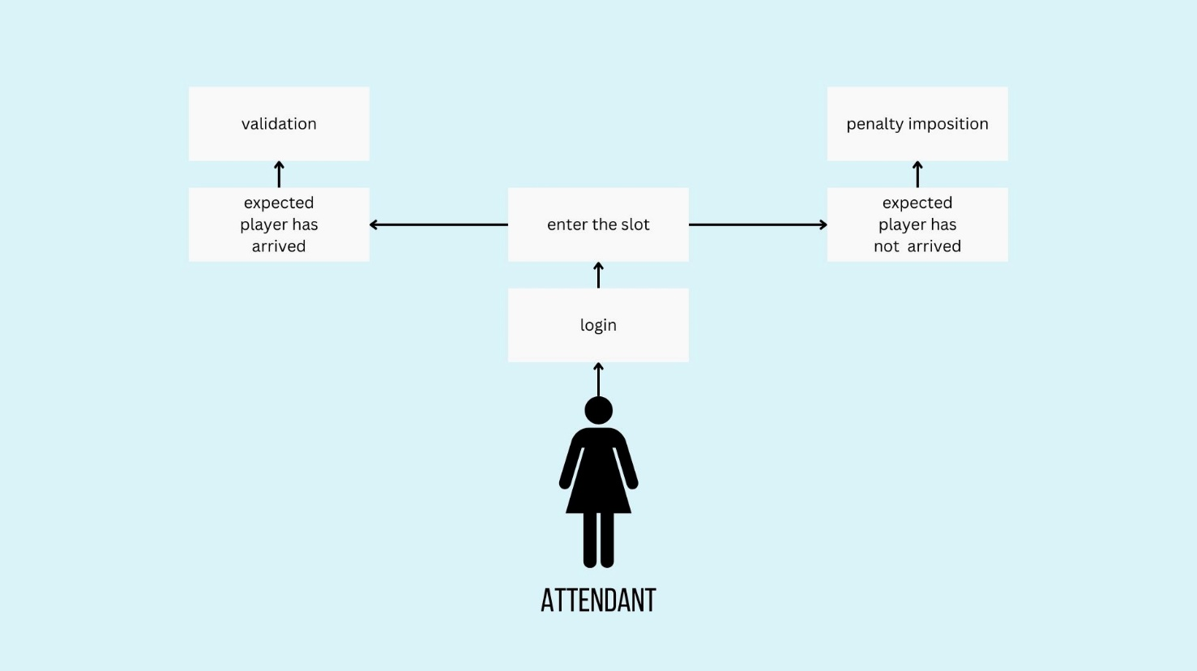**Exception** - Under the coach's order or request, whereby a booked slot can be allocated to the coach's designated person.

# Other Non-functional Requirements

## Performance Requirements

* **Concurrency** - The platform can handle 500 concurrent users.
* **Responsiveness** - Average response time below 1 second at launch for a seamless user experience. Average response time under 3 seconds during normal operation.
* **Resource Efficiency** - Adhere to industry best practices for storage, memory, and processing to minimize resource consumption.

## Safety and Security Requirements

* Proper login mechanisms should be used to avoid hacking.
* Periodic and safe backup of the entire database will be taken to ensure no loss of data
* Secure and reliable transmission of information
* Secure storage of passwords will be done after salting and hashing the passwords. In other words, the system admin can only verify if the password is correct but won’t know what the password submitted by the user was to prevent eavesdroppers from getting the information.
* The minimum set of browsers that have the required safety standards are:
  + Apple Safari 7+
  + Google Chrome 44+
  + Microsoft Edge 90+
  + Mozilla Firefox 40+.
* A notification will be sent to the concerned people whenever a transaction is added.

The user will not be allowed to set weak passwords. Weak passwords have been defined as passwords possessing any one of the following qualities: -

* Length less than 8 characters
* Containing solely lowercase/uppercase alphabets
* Having a commonly used phrase, examples of which will be stored in the database
* There will be CAPTCHA system to avoid DDOS attacks.

Secure connections to payment gateways like SBI I-Collect to ensure proper execution of monetary transactions.

‘Forgot password’ features with authentication by security questions to avoid misuse.

## Software Quality Attributes

* + 1. **Maintainability**
* The architecture, design, implementation and documentation of the software must be such that they make the system reduce maintenance overhead as much as possible.
* Fixing a security defect, including updating of the documentation and testing, must not take more than two working days. This is done by making the software as modular as possible
* The average work time required to add a minor feature, including documentation, unit testing, should be less than one person a week.
  + 1. **Availability**
* In case of a server crash, the system state must be restored within two hours.
* Sports booking with see a boom just after exams as more people are free. The system availability needs to be enough for this purpose.
* A lot of sports camps are conducted during the summer break and other vacations. The system should be robust enough to provide all the functions of the calendar and booking in the peak time.
  + 1. **Reliability**
* The MTTF (Mean time to failure) shall be more than one week.
* The system must undergo extensive feature testing, load testing, and regression testing prior to release and/or deployment.
* The system should be reliable in giving correct results consistently.
  + 1. **Portability**

We are using ReactJS design the front-end part of our application, thus our application is portable, responsive and can run on any modern web browser.

Appendix A – Data Dictionary

1. **User Class**

|  |  |
| --- | --- |
| **Description** | All users of the software |
| **Class variables** | * name: string * mail_id : string * user_id : int * password: string |
| **Methods** | * register_user * login * logout * reset password * delete account * rename |
| **Relationships** | This is the master user class; it will have subclasses for normal user and super user (coaches and counsellors) |

1. **Normal User Class**

|  |  |
| --- | --- |
| **Description** | Clients wishing to avail the applications services |
| **Class variables** | * sports: sports object * booked_slots : booking type |
| **Methods** | * book_slot * book_session |
| **Relationships** | This is a sub class of the user class |

1. **Super User Class**

|  |  |
| --- | --- |
| **Description** | Coaches for sports and counsellors, who can reserve slots for team practice/sessions |
| **Class variables** | * type: string * reserved_slots : booking type * domain: string |
| **Methods** | * reserve_slot * schedule_workshop |
| **Relationships** | This is a sub class of the user class |

1. **Sport Class**

|  |  |
| --- | --- |
| **Description** | This class contains information about each sport |
| **Class variables** | * min_players : int * max_players : int * tutorial_links : list of strings * ladder: list * courts_available : bool |
| **Methods** | * edit_sport |
| **Relationships** | Objects of this class provide details about the sport for the purpose of slot booking, tutorial showing to the user etc. |

1. **Booking Class**

|  |  |
| --- | --- |
| **Description** | This class stands for a booking of a court for a fixed duration of time |
| **Class variables** | * time: pair of start time and end time * date: date type * venue: string * domain: string |
| **Methods** | * find_opponent * book_equipment |
| **Relationships** | This class is used by user/super user to book/reserve slots of their choice |

Appendix B - Group Log

|  |  |  |  |
| --- | --- | --- | --- |
| **Date** | **Timings** | **Duration** | **Minutes** |
| 08 Jan | 21:00 – 23:00 | 2hrs | Idea Suggestions by everyone.  Main Ideas proposed were:   * Sports Booking Facility * Carpooling System * Election Management System * Internship Scheduler * Medical Facilities Appointments |
| 09 Jan | 22:00 – 00:00 | 2hrs | * Preliminary discussion on feasibility and usefulness of ideas. * Felt that there is a lot of hassle involved in using the sports facilities and there was a lack of a unified system to manage the same. * Decided to implement a software solution for the same. * Finalized Sports Booking System. |
| 10 Jan | 21:00 – 22:00 | 1hr | * Finalized the description of the project and named the project as “Elysium”. * Discussed the startup project idea floated in the mail. |
| 15 Jan | 21:00 – 00:00 | 3hrs | * Started work on the SRS document. * Discussed UI and functional requirements. |
| 18 Jan | 16:00 – 16:30 | 30min | * Discussed the project idea with the mentor TA Mr. Sarthak Neema. * We also discussed the various frameworks to be used in frontend and backend of this software. |
| 19 Jan | 22:00 – 00:00 | 2hrs | * Formalized the features of the software. * Exploration of possible implementation, challenges. * Divided the various sections of the SRS document amongst ourselves. |
| 22 Jan | 22:00 – 01:00 | 3hrs | * Raised and settled contentions regarding various use cases, features and the algorithm to be used in the software. * Finalised the main features of pair-matching and slot-booking systems and documented it in the SRS. |
| 24 Jan | 23:00 - 2:00 | 3hrs | * Created the first draft of the SRS document. |
| 26 Jan | 17:00 - 19:30 | 2hrs 30min | * Proofread the whole document. * Raised contentions and corrected them. |